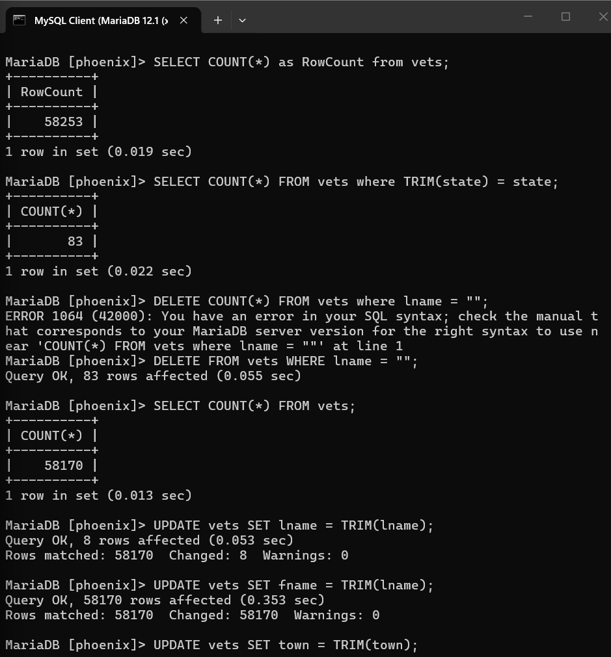
2. Run the query:
SELECT count(*) FROM vets where trim(state) = state;
What do you think this implies?
This checks the Trimmed version for every instance(without spaces before or after the key).

Switched to vets2 table because i accidentally copied name into fname
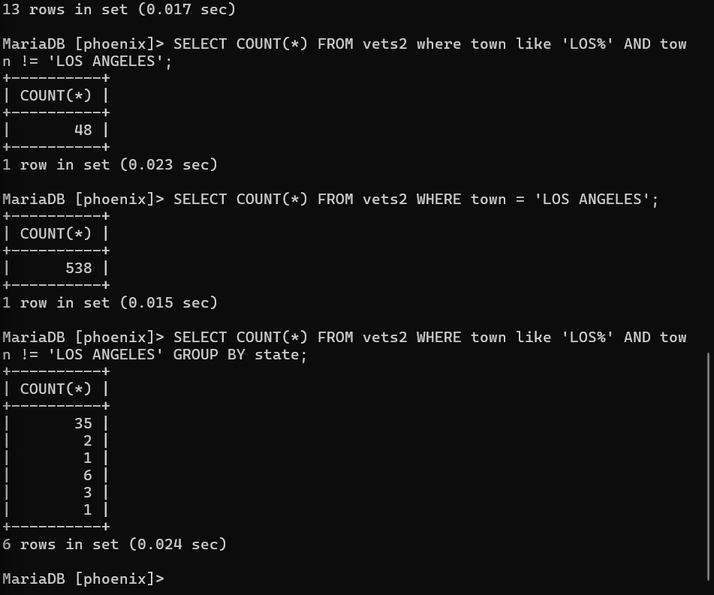
Count the rows that are like los but not los angeles. Shows the towns that are in los angeles. Shows the grouped form of the count of los angeles states and towns.

